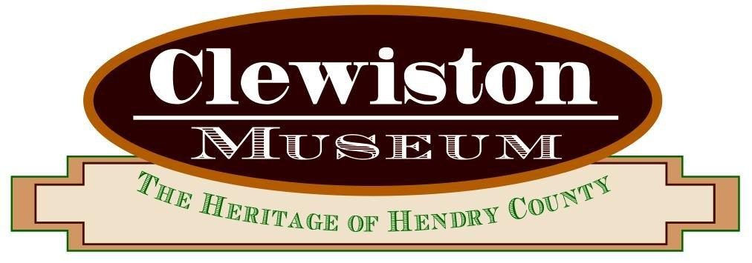

Please complete the information below and mail your check to:

The Clewiston Museum, 109 Central Avenue, Clewiston, FL 33440

Make checks payable to The Clewiston Museum. For credit card processing, please contact the Museum office at 863-983-2870.

Annual Dues for the Friends of the Museum

Name: ___________________________

Address: _________________________

City, State, Zip: ___________________

Phone: _______________________

Individual $25 ____

Family $75 ____

Sponsor $100 ____

Patron $150 ____

Corporate $250 ____

Please include your email address, so we can keep you updated on museum

activities. _________________________________________________

SPECIAL DONATION

Building Maintenance $______

